Database Description
The online food truck ordering system is designed to facilitate the ordering and management of food trucks. It consists of several entities, including users, managers, employees, food trucks, food truck schedules, items, item orders, and orders. Customers can place orders for food items from the available food trucks. Each user has a unique ID, first name, last name, password, and email. Food trucks have a unique ID, name, description, image, location, manager, employees, items, and schedules. Managers and employees have a unique ID, first name, last name, password, email, and a reference to the food truck they manage or work at.

The food truck schedule entity stores the schedules for each food truck, with each schedule having a unique ID, a day, start time, end time, location, food truck ID, and orders. The items entity contains a unique ID, name, price, quantity, image, category, description, and a reference to the food truck it belongs to. An item order is an order for a specific food item, with each item order having a unique ID, quantity, price, creation date and time, item ID, and order ID.

An order is an order placed by a user for a set of food items from a food truck schedule. Each order has a unique ID, creation date and time, total amount, pickup time, food truck schedule ID, user ID, and item orders. Foreign keys are used to establish relationships between entities, such as the relationship between a manager or employee and a food truck, or between a food truck and its items. Constraints are also included to ensure data consistency and integrity, such as unique constraints on email and IDs, and cascading deletes and updates to ensure data is properly maintained across related entities.
Cancellation and Refunds:
Users can cancel their order. On cancellation the payment status is set to “CANCELLED”.

Pickup:
While placing the order user has to choose the pickup time based on the schedule of the food truck he is placing order from.

NoSql database model

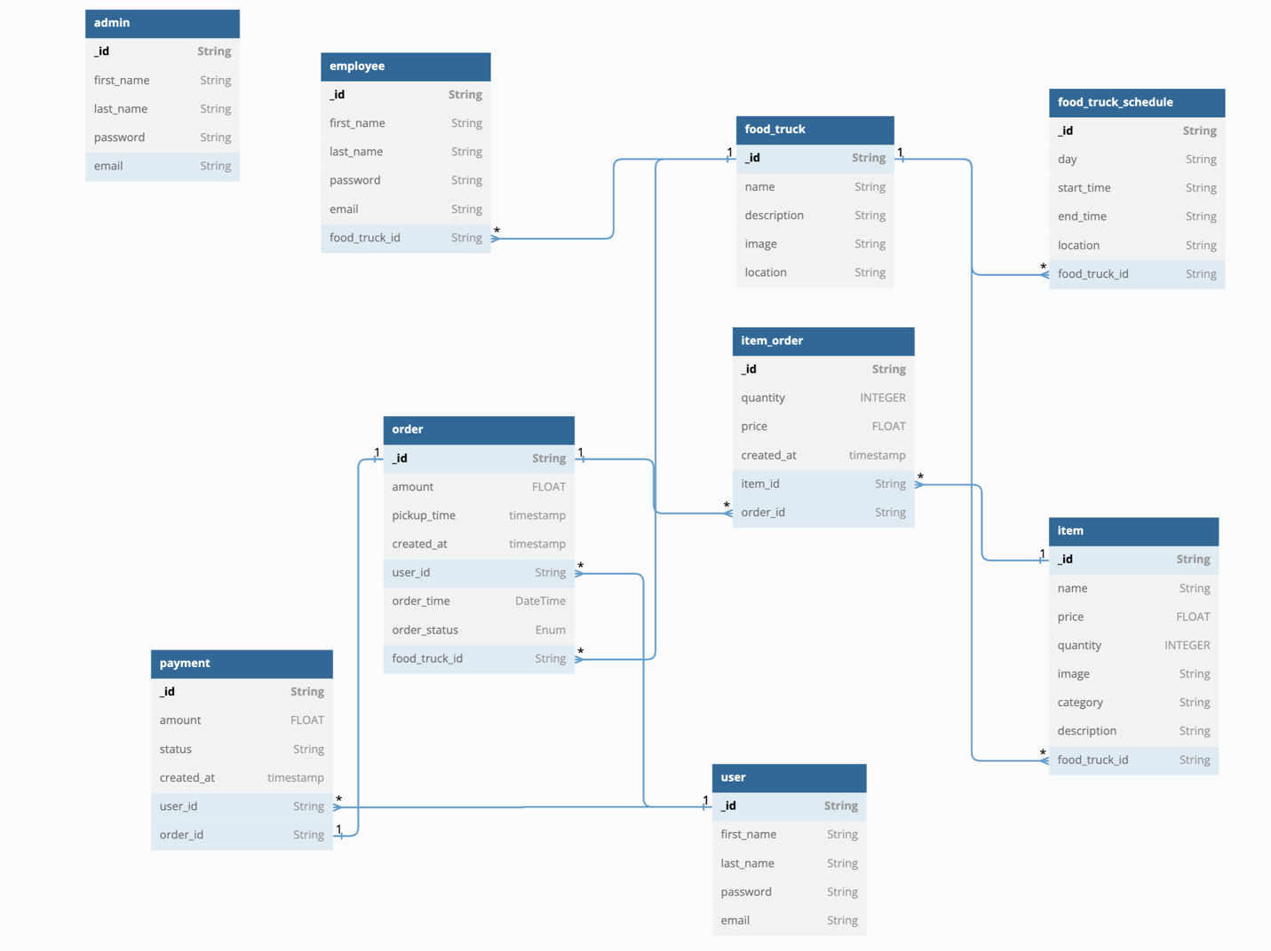

Sample data

